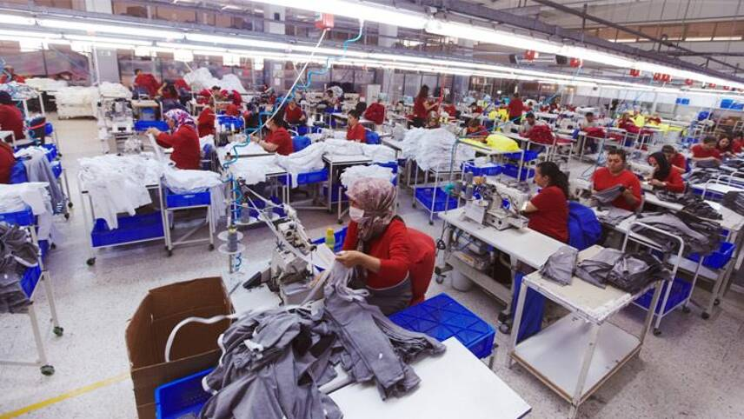

The Revolution of the Fashion Industry’s Supply Chains Post-COVID-19
  - how shein did it better than zara
38802139

Introduction- Inditex vs. Shein
Just before the pandemic, Inditex- the parent company of household fashion names such as Zara and Bershka- had the second strongest supply chain in the world, according to Gartner’s Supply Chain Top 25 ranking of 2019. As a mere fashion company, its’ supply chain dominated against some of the highest-grossing companies in the world from even bigger industries, such as Nestle, Intel and Walmart¹.
Over the next consecutive years, it fell to ninth place², then 13^{th 3}, then 18^{th 4}. In 2023, it managed to recover back to 13th place⁵. Of course, the Gartner Top 25 ranking is not a perfect measure as supply chains are incredibly complex mechanisms, and it is arguably inappropriate to compare one companies’ supply chain against another’s. However, this data goes to show the mid/long-term impact that the pandemic had on Inditex’s supply chain robustness.
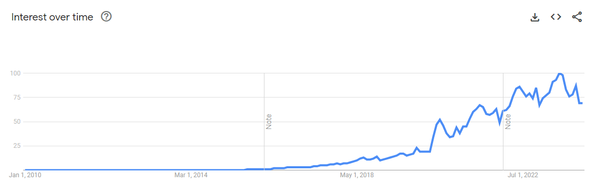
One company that has never been named on this list is Shein, and due to its’ controversial practices, it is unlikely to ever be named a top 25 supply chain. Shein is known for their suspiciously cheaply priced clothing, as well as their numerous lawsuits and investigations against them, such as racketeering, tax law abuses, and allegations of forced labour⁶. Despite this, (or arguably because of this,) the mysterious online fast fashion brand has seen an exponential rise, very much thanks to the pandemic. The company was founded in 2008 as ZZKKO, which is almost surprising to some, as it only began to gather any sort of attention around 2016, according to Google Trends (figure 1). They didn’t need to stabilize their supply chain after this external shock, which was catastrophic to most of the economy- on the contrary- they thrived and became what they are now because of it.
Figure 1- Google Trends data, Interest over time for Shein
Zara, Bershka and most other retailers who rely heavily (or completely) on brick-and-mortar stores, suffered heavy losses in sales and demand, due to global quarantines and supply chain shocks. Customers could no longer purchase products in shops, shipments were cancelled, and the flow of raw materials and finished goods was disrupted, which additionally resulted in disruptions at the manufacturing end of the supply chain- like a bullwhip effect on a massive scale, and with fluctuations at both ends of the metaphorical whip. Inditex managed to stabilize relatively quickly and efficiently, by adjusting their supply chain and business model to cater to online shoppers. However countless retailers that couldn’t adapt in time were forced to lay off staff, close stores, or even file for bankruptcy. This list contains former high-street giants such as Debenhams, Topshop and JCPenney⁷.
Meanwhile, a revolution was beginning in the fashion industry among companies whose supply chains were better suited to this shock, mainly by being able to switch to (or already being based) online. This sort of direct-to-customer business model was becoming a necessity, and some companies were better or worse equipped to deal with the unprecedented need to cut out of the ‘middleman’ in the form of physical shops. Not only was this extra step in the supply chain suddenly shut off, but some companies realized it was just an unnecessary cost money wise, as well as time wise. Shein realized this quickly and used the coronavirus pandemic as a trampoline to build a global, online fashion giant that can produce hundreds of thousands of new products a week, and still manage to get these products delivered from one end of the supply chain straight to the customers front door within a couple of weeks- a process that usually takes other companies several months.
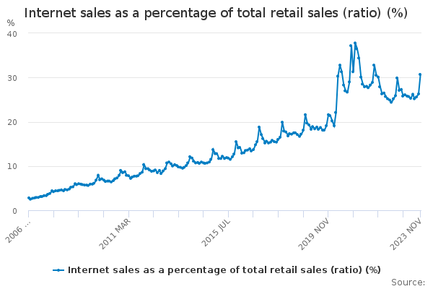
Fast Fashion Supply Chain Requirements: Pre- and Post-Covid
Traditionally in fast fashion supply chain strategy, according to (Tokatli, 2008)¹¹, there are five requirements. One of the biggest requirements was having retailers with ‘rapidly increasing numbers of stores worldwide’ to reach as many customers globally as possible. Even at the height of the pandemic, the proportion of internet sales as a percentage of total retail sales barely peaked at 40% (figure 2), which shows the importance of brick-and-mortar stores- consumers simply prefer to try on their clothes in person. Zara’s ‘destination appeal’ also helped Inditex recover when retail stores started reopening, thanks to their ‘bright, spacious and modern’ shops with fitting rooms, as well as the introduction of their new Zara Beauty range with fragrances that you can only smell in person, to drive footfall¹².
Figure 2- Source: Data from https://www.ons.gov.uk
Zara had 2,312 stores globally as of 2022, however this number has decreased yearly since the pandemic- in 2019 they peaked at 2,866 stores¹³. The reason for this decline is a combination of the need to mitigate costs by temporarily shutting down stores, as well as a strategic decision to adapt to the increasing shift in consumer behaviour towards online shopping, therefore focusing more investment to this sales channel. This is a significant supply chain challenge that Inditex handled well, thanks to their already diverse multi-channel selling of merchandise. Zara already had a significant online presence before the pandemic unlike many traditional fashion brands, therefore overall loss in performance was mitigated as they had other successful channels they could rely on other than physical shops.
It may seem that this is an Achilles’ Heel for Shein, being online-only. However, they have also taken advantage of multi-channel selling, with temporary pop-up ‘tours’ across Europe¹⁴, starting as soon as covid restrictions began getting lifted. These ‘concert-tour’-style events build further hype and exclusivity for their brand. This proves that Shein is aware of the power of bricks and mortar, and allows them to harness this power for an extra performance boost without having to invest additionally into permanent retail stores.

Zara and Shein have both mastered efficient production timelines, with ‘super-responsive’ and ‘rapid-fire’ supply chains, that ‘make certain that deliveries are sufficiently frequent’-which happens to be Tokatli’s fourth requirement in fast fashion. Zara, just like the rest of the economy, though, were unavoidably disrupted during the pandemic by delayed shipments and cancellations, causing their deliveries to not be as frequent as usual. Regardless of this, one of the bottlenecks of any fast fashion brand’s supply chain is predicting design trends, communicating this information to designers and production staff, and then getting the items manufactured and shipped, in order to get the most fashionable clothing into the customers hands before they become outdated. This necessity to ‘connect customers' demand with the upstream operations of design, procurement, production, and distribution,’ is Tokatli’s second requirement. Shein had pioneered a solution to this problem by developing an information algorithm, utilising artificial intelligence to identify popular designs automatically, and getting them communicated to producers as quickly as possible. This allows their supply strategy to be even more pull based, and allows faster responsiveness to customer demand. Unfortunately, this solution had backfired for them, as these algorithms sometimes resulted in direct plagiarism, which caused an addition to their list of legal troubles. This highlights a potential trade-off between efficiency and ethical considerations in their supply chain management.
It is highly likely this solution was made possible indirectly by the pandemic. Despite the economic slowdown in other sectors, the AI industry saw strong growth in 2020, thanks to a growth of total global investment in AI of 40% from 2019-2020, compared to only 12% from 2018-2019¹⁵. Most industries were forced to invest more into their information technology to adjust to the shift to online, and artificial intelligence at the time was an emergingly promising IT tool. This suggests interdependence between industries and how even a global crisis often has its silver linings- Shein took advantage of an emerging technology in an unconventional way to improve their supply chain.

‘Third, fast fashion requires short development cycles, rapid prototyping, small batches and variety so that customers are offered the latest designs in limited quantities that ensure a sort of exclusivity.’ Shein has mastered ‘micro-batching,’ ordering as little as 50-100 pieces from their suppliers at a time, and swiftly reordering if that particular SKU is successful so it can be put back on their online shelves¹⁶. This extreme case of ‘just-in-time’ strategy is risky, since due to the unusually low batch sizes, their suppliers often lose money on such orders. However, these losses are countered quickly, as popular products can be re-ordered straight away in as high of a quantity as is necessary. Thanks to Shein’s aligned supply chain, they have enormous amounts of control over their suppliers, and they support their factories with investment to build up their ‘small order quick response’ system. Shein unfortunately refuses to confirm information about its’ supplier network, but import records show that virtually all Shein’s ocean shipments to the US come from China¹⁷- another source states Shein insists their manufacturing contractors are all situated locally in the Chinese city of Guangzhou¹⁶, which means they can manage them more easily because of the proximity. This combined with their unique digitised communication systems with automated algorithms, provides them with a short and tight supply chain that may be volatile, but it is one that they have full control over and allows their development cycle to be uniquely cheap and effective.
Inditex also operates similarly, with lean production cycles and small batch sizes, however a key difference in the production end of their supply chain is that their suppliers are all over the world. 98% of their production is based in 12 countries (one of which is China), and almost all their clothing is sent to distribution centres in Spain. However, before the pandemic, a lot more of their production was based in China- the country was Inditex’ largest supplier, with 449 partners in 2018, an increase of 24 from the year before¹⁹. This began changing after the pandemic, as Zara began decoupling from China, and relying more on their other suppliers. According to Yogaananthan (2020)²⁰, to build a resilient supply chain post-covid, firms should diversify supply chains through multi-sourcing, as well as avoiding completely relying on China; and Zara has followed both successfully. Meanwhile, Shein seems to rely solely on their home country for both production and distribution. Yoganaanthan also states that diversification complicates the supply chain and makes it more difficult to manage. Shein’s strategy of centralization rather than diversification seems to work perfectly for them, and allows them more direct control and alignment over their supply chain.
This may not be possible for firms based outside of China, though- especially after the pandemic. Covid was a contributor in intensifying political and financial tensions between China and the rest of the world, especially the US, in the form of tariff wars, import bans, and general distrust, which deteriorated trade relationships permanently²¹. This resulted in difficulties for foreign firms such as Inditex, but in a way helped Shein develop. Inditex and other companies who ship all products in bulk from warehouses to retail stores, have no way of avoiding import/export taxes. Shein on the other hand, manages distribution domestically, and exports individual customer orders from warehouses in China. In the US, the duty threshold on which imported packages are taxed is $800, meaning an average customer’s ‘#sheinhaul’ (a hashtag which has 14.6 billion views on TikTok²²) will not be taxed. As a result of this international trade war (which was largely stimulated by the “Chinese virus”), as well as support from their own government, Shein has been able to exploit tax loopholes, cutting costs on both imports and exports²³.

‘Finally, because most fast fashion retailers are publicly traded companies and their success is now measured by stock performance, they are increasingly under pressure to perform well on the stock markets.’ Inditex has been publicly traded since 2001, and Shein has very recently filed for a US IPO²⁴, despite in 2021 claiming to have ‘no IPO plans in the short term’²³. This would be good news for their growth, as it would bring them major third-party investment. It would also force them to be more transparent with their supply chain and business practices- as a private firm, they are not complying with due diligence supply chain laws to disclose any financial or operational information, and until recently have been deliberately secretive. The fashion industry in general is notorious for their questionable labour ethics, and Shein has particularly been under scrutiny for attempting to hide and deny theirs. Especially after the revolution in workplace health and safety and labour laws due to the pandemic, this will very likely require them to put more effort into making sure their workers are treated and paid fairly, and there has been increasing demand from potential investors, campaigners, and other shareholders for Shein to do so. This should prompt their supply chain to become more aligned with environmental, social and governance management expectations, and make them a more sustainable and corporately responsible company.

Conclusion
The Covid-19 pandemic was an unprecedented shock to the whole economy, transforming all industries worldwide. In this era, the global fashion industry, represented by companies like Shein and Inditex, went through a litmus test that highlighted the importance of supply chains' resilience, adaptability, and agility. Unfortunately, many companies fell victim to this crisis and were not able to fully recover. Meanwhile for others it was an opportunity for new growth and expansion.
Inditex did inevitably suffer from the supply and demand-side shocks, due to the disruption in international logistics which led to delays and backlogs, and the lockdowns which cut off an enormous quantity of sales from retail stores- an extreme example of the bullwhip effect in motion. However, their agile supply chain allowed them to easily adapt by enhancing their existing online presence. Since most of their inventory was held strategically in centralised warehouses in Spain, this allowed them to simply redirect shipments from retail stores to direct consumer delivery, without the need for reconsideration of their whole model.
On the other hand, Shein is a case study on capitalising from a crisis. As a digital-first enterprise, they were entirely ready for this shift in consumer behaviour- it is possible that they were just at the right place at the right time. They did get a lot of things right, though, that many other online retailers did not. Not much is known about Chris Xu, the elusive CEO of Shein, but it is not surprising that he has a background in Search Engine Optimisation and is a marketing specialist. This sort of technical expertise is largely what Shein owes their success to, as well as their clever marketing. The company’s main advantage over other online retailers was their integration of innovative algorithms and AI, whos’ growth was accelerated thanks to the pandemic, to speed up and automate all aspects of its’ supply chain to levels no other fashion company has done before, displaying an advanced form of resilience. Unfortunately, the trade-off for these tactics was backlash, lawsuits, and allegations, and Shein’s denial and secrecy only fueled suspicion around their practices.
These cases highlight some key implications for supply chain management in the face of external shocks, such as the ability to pivot between sales channels to follow where demand leads, specifically realizing the power of e-commerce and digital platforms. As seen in Figure 1, the trend in the last 20 years is heading towards internet sales becoming the majority of total retail sales. Evidence of this can also be seen in the form of high streets becoming increasingly empty over the last decade, with the pandemic being a last nail in the coffin for some retailers. Of course, this shift is not as necessary or relevant for all industries, but this structural change is important to consider when making SCM decisions.
However, is this a question of lack of resiliency, if a product or service you provide unexpectedly becomes obsolete? For example, is it fair to say Blockbuster was not ‘agile’ or ‘resilient’ enough for not becoming like Netflix? Was Topshop not agile enough for not developing an online shop earlier, and not expecting to have to close their shops, almost overnight, if they were performing well and meeting expectations? Many retailers seemed to be over-reliant in their status as ‘kings of the high street’⁷, which may have given them a false sense of confidence and allowed management to put all their eggs in one basket without sufficient ‘futureproofing’. I believe part of supply chain resilience is to expect the unexpected, and always be ready for the worst-case scenario.
Lastly, ethical, environmental, and social issues (ESG general) are becoming a hot topic across all industries. Unfortunately, no big corporation is innocent when it comes to this- increasing amounts of companies are being accused of either some sort of controversy, or at least ‘greenwashing,’ to appear more sustainable than they really are- ‘opacity has become the norm’²⁵. Shein is no stranger to this- until recently, they have made the deliberate decision to stay private, however they are recently considering trading publicly, which will open them to investors as well as forcing them to be more transparent. They have committed to ‘realise a fully circular fashion and textile industry by 2050’²⁶, which sounds very vague, and could be another case of greenwashing. However, there seems to be societal changes coming, with increasing talk and protests about climate change and pollution, so these expectations could very well become requirements for supply chains globally. Assuming this is a genuine step in the right direction for Shein and the fast fashion industry, this could allow Shein to make it to Gartner’s Top 25 list one day.

Appendix
The following section was meant to be part of the introduction, however was removed to fit the word count, and I also realised that its probably not relevant or necessary:
What is ‘Fast Fashion’?
It is difficult to pinpoint exactly when fast fashion became ‘fast.’ There is evidence that suggests humans first started sewing fabrics together using thin bones and rocks to make fitted pieces of clothing around 40,000 years ago⁸. The history of the modern sewing machine is fairly recent, with many people claiming to have invented it around the 19th century⁹. The way a sewing machine works is surprisingly complicated, but the exponential evolution of this technology in the last couple of centuries has revolutionised fashion, and allowed good quality clothing to be made very quickly, and helped fashion become incredibly accessible and affordable to anybody. Since the industrial revolution, demand for cheap, replaceable clothing has been steadily increasing at an enormous rate, and therefore people of all classes’ wardrobes have also been growing.
Nowadays, most clothing is mass-manufactured using automated production lines in factories, producing more than 100 billion items of clothing a year. China is the biggest powerhouse of these clothing factories, with around 65% of clothing being produced there. Additionally, thanks to the ‘third era of globalisation’ starting in 1989¹⁰, these items of clothing can be exported to and from anywhere across the globe in a matter of days. As a result, the fashion industry has become one of the biggest industries, with very low barriers to entry to start a small clothing brand. However, to become a multi-billion-dollar brand like Inditex or Shein requires more than just creating, producing, and selling a couple of nice designs. An Agile, Adaptable, and Aligned supply chain is required to be able to manufacture and distribute the clothing (Lee, 2004), and this involves many interdependent moving parts across the globe.

References
¹ https://www.gartner.com/en/newsroom/press-releases/2019-05-16-gartner-announces-rankings-of-the-2019-supply-chain-t
² https://www.gartner.com/en/newsroom/press-releases/2020-05-20-gartner-announces-rankings-of-the-2020-supply-chain-top-25
³ https://www.gartner.com/en/newsroom/press-releases/2021-05-19-gartner-announces-rankings-of-the-2021-supply-chain-top-25
⁴ https://www.gartner.com/en/newsroom/press-releases/2022-05-26-gartner-announces-rankings-of-the-2022-global-supply-chain-top-25
⁵ https://www.gartner.com/en/articles/these-are-the-best-supply-chains-of-2023
⁶ https://www.npr.org/2023/10/13/1204983212/shein-america-fast-fashion-legal-issues
⁷ https://fashionunited.uk/news/business/2020-fall-of-fashion-brands-retailers-and-series-of-chapter-11-bankruptcies/2020122852707
⁸ https://www.sciencefocus.com/science/when-did-humans-first-start-wearing-clothes
⁹ https://www.youtube.com/watch?v=RQYuyHNLPTQ
¹⁰ https://archive.nordregio.se/en/Metameny/About-Nordregio/Journal-of-Nordregio/2008/Journal-of-Nordregio-no-1-2008/The-Three-Waves-of-Globalisation/index.html
¹¹ Tokatli, N. (2008). Global sourcing: insights from the global clothing industry—the case of Zara, a fast fashion retailer. Journal of Economic Geography, 8(1), 21–38. http://www.jstor.org/stable/26161238
¹² https://www.just-style.com/news/destination-appeal-aids-inditex-in-retail-reopening/?cf-view&cf-closed
¹³ https://www.inditex.com/itxcomweb/en/investors/finance#accounts-reports
¹⁴ https://m.shein.co.uk/campaign/shein-euro
¹⁵ https://hai.stanford.edu/news/how-has-covid-affected-ai-economy
¹⁶ https://gadallon.substack.com/p/unraveling-sheins-supply-chain-foundation
¹⁷ https://www.reuters.com/business/retail-consumer/shein-shifts-shipping-strategy-bring-china-made-goods-closer-us-shoppers-2023-09-22/
¹⁸ https://www.reuters.com/business/retail-consumer/how-shein-outgrew-zara-hm-pioneered-fast-fashion-20-2023-12-13/
¹⁹ https://www.themds.com/companies/inditex-sourcing-where-does-zara-owner-make-its-clothes.html
²⁰ Yogaananthan. (2020). Building resilient supply chains: Three strategies. In BUILDING CRITICAL SUPPLY CHAIN RESILIENCE IN THE WAKE OF COVID-19 (pp. 8–12). S. Rajaratnam School of International Studies. http://www.jstor.org/stable/resrep25424.6
²¹ Lehr, A. K., & Wu, H. C. (2021). Global Trends in Textile, Apparel, and Footwear Sourcing. In Addressing Forced Labor in the Xinjiang Uyghur Autonomous Region: Collective Action to Develop New Sourcing Opportunities (pp. 4–8). Center for Strategic and International Studies (CSIS). http://www.jstor.org/stable/resrep28662.6
²² https://www.tiktok.com/tag/sheinhaul?lang=en
²³ https://www.supplychainbrain.com/articles/33257-how-trumps-trade-war-built-shein-chinas-first-global-fashion-giant
²⁴ https://www.reuters.com/markets/deals/chinese-fast-fashion-shein-files-us-ipo-wsj-2023-11-27/
²⁵ https://www.theinterline.com/2023/06/30/shein-and-the-smoke-and-mirrors-supply-chain/
²⁶ https://www.sheingroup.com/corporate-news/circularity-at-shein-how-were-building-circular-systems/

